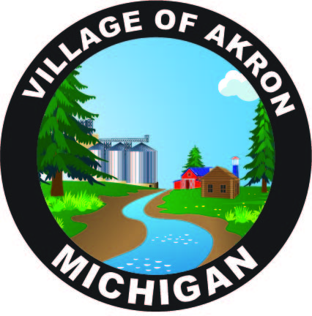

VILLAGE OF AKRON

SPECIAL COUNCIL AGENDA

JANUARY 20, 2025

DEPARTMENT OF PUBLIC WORKS INTERVIEWS

1. PLEDGE OF ALLEGIANCE

2. ROLL CALL

3. INTERVIEWS

4. PUBLIC COMMENT

ADJOURNMENT